JavaFx
java application has gui that contains button,list ,checkboxes, menus,toolbar, and many other.
JavaFx has set of Api’s , which are just packages which are successor to swing.
You can use this to build desktop application, internet application and mobile devices.
Javafx software: javafx
-Everytime in a new project u have to put javafx to build UI, so put it in a known folder.
So in my case its in C:Kazim_softwares
Then you have to put the software in global library in IntelliJ so u can add that library on the fly.
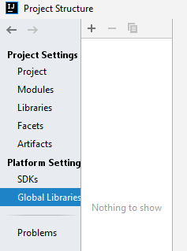

Next step is to find the javafx folder>lib> (select all jar files)

Lec 181 :Create your JavaFx project
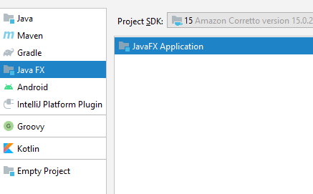

Tip: Type fx at the end of project name: for e.g HelloWorldFx
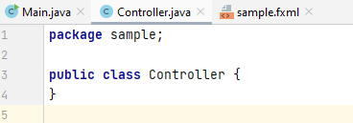

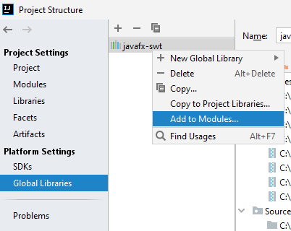

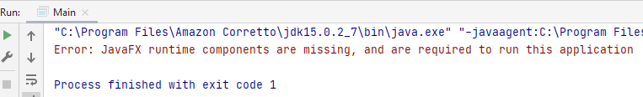
This means the library is been added but u need to configure.
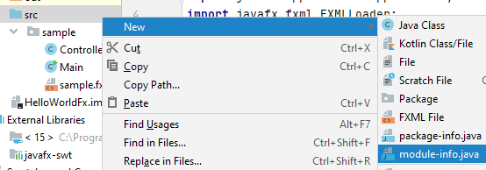
If u dont see module-info.java there is problem with ur project settings.
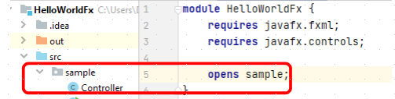

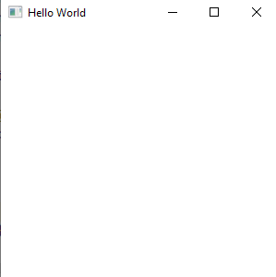

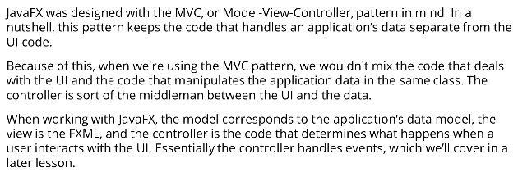
Thats why we are given : Sample.fxml, Main, Controller.
Javafx dont force the MVC pattern but its a good practice to follow.
We only have windows control I.e Minimize, Maximize and control.
- javafx must have a class that extends application class and this class will be the entry point to the application. The application class manages the lifecycle of a javaFx application.
- The methods of Application class that we really care about are the init method, the start method and the stop method. When we run the application, application.launch will be called from Main. This method launches the javafx application and doesnt return until the application is exited.
When javafx application is launched the init method is runned first. Its an abract method. The start method runs after the init method. Start method is also a abstract method.
When u closes the window, the stop method runs. This method is empty too.
Stage is a top level javafx container that extends window class. Essentially its the main window. The javafx runtime passes the intial stage and passes it into the start method.
We can create other stages but most applications will only have one top level window. Too many windy leads to a bad user experience.

Dialogues are presented with a stage but we dont explicitly create the stage. We use the dialogue class which wraps the dialogue into a stage forest.
Loads the UI from the FXML file.
FXML is a flavour of Xml.
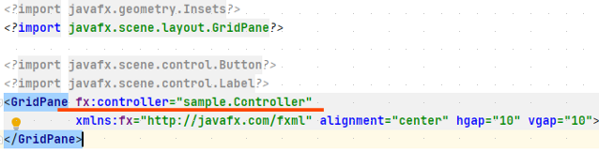
Fx : controller attribute tells which class is the controller for this window. So sample is our package name and controller our Controller class.
The GridPane doesnt have any child elements and so when we run our application in the previous video. So our window is empty.

When we load the fxml file, all of the UI components in the file are constructed.
Each stage requires a scene, and backing each scene is a scene graph a tree which each node corresponds to a UI control or an area of the scene.
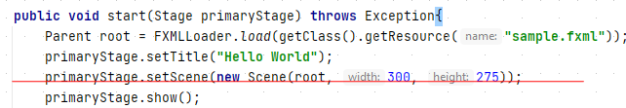
When we load fxml we assign it to a variable of type parent with name root.
The parent class descends directly from the node class, which is base class for scene graph nodes.
Note descend from parent can have children in the same graph. For HelloWorld application in fact only node is the GridPane.

GridPane node will be the root of the scene graph and that was returned from the fxmlloader.load().
When we construct the scene we need to pass in the scene graph that will back the scene.
We are also setting the width and height of the scene.
So why do u have a scene with a stage.
So in a theatre the curtain rises when u watch the scene then the curtains falls the stagehands run around and change the furniture and backdrop and then the curtain rises again.

